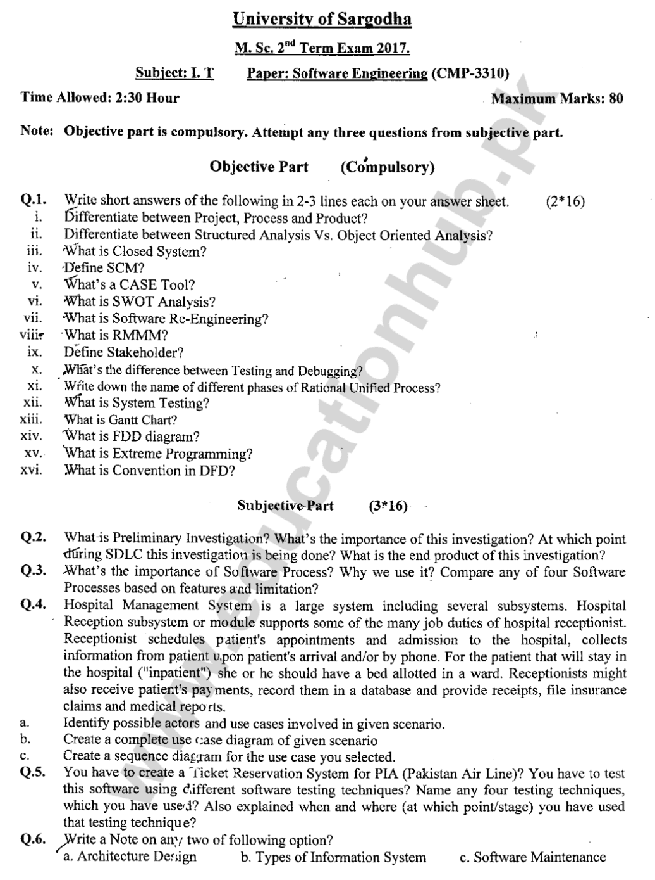

**SHORT ANSWERS:**

**1.Differentiate between Project, Process and Product?**

|  |  |  |
| --- | --- | --- |
| **PROJECT** | **PROCESS** | **PRODUCT** |
| A project is a temporary endeavor, with a clear definition of what needs to be delivered and by when. A project has a beginning and end date. | A Process is a set of related activities that leads to the production of the software. These activities may involve the development of the software from the scratch or modifying an existing system. | A product is designed to continually create value for customers by solving their problems. Products have more permanence, are living entities which we deliver quickly, iterate constantly, and are not something that we just walk away from. |

**2. Differentiate between Structured Analysis and Object Oriented Analysis?**

|  |  |
| --- | --- |
| **Structured Analysis** | **Object Oriented Analysis** |
| In this the focus is only on process and procedures. Modeling techniques used in it are DFD (Data Flow Diagram), Flowcharts etc. This approach is old and is not preferred. | In this we put more focus on capturing the real world objects in the current scenario that are of importance to the system. It stresses more on data structure and less on procedural structure. |

**3.What is Closed System?**

A system in which the specifications are kept secret to prevent interference from third parties. It inhibits third-party software from being installed; it keeps third-party hardware from interoperating with it, and it prevents third-party enhancements from improving the product.

**4. Define SCM?**

Software configuration management (SCM) is a set of activities that have been developed to manage change throughout the life cycle of computer software. SCM is a software quality assurance activity that is applied throughout the software process.

**5. What’s a CASE Tool?**

CASE tools are set of software application programs, which are used to automate SDLC activities. CASE tools are used by software project managers, analysts and engineers to develop software system.

**6. What is SWOT Analysis?**

SWOT Analysis is a management review in strategic planning. SWOT stands for strengths, weaknesses, opportunities, and threats of a project going to start. A SWOT analysis usually starts with a broad overview of the whole system.

**7. What is Software Re-Engineering?**

Software reengineering is an approach used by analysts during software maintenance. Software reengineering uses analytical techniques to identify potential quality and performance improvements in an information system. Software reengineering is used to simplify operations, reduce costs, and improve quality.

**8. What is RMMM?**

RMMM is a risk management strategy that can be defined as a software project plan or the risk management steps. It can be organized into a separate Risk Mitigation, Monitoring and Management Plan. The RMMM plan documents all work performed as part of risk analysis and are used by the project manager as part of the overall project plan.

**9. Define Stakeholder?**

People who have an interest in an information system are called **stakeholders**. Stakeholders include the management group responsible for the system, the **users**(sometimes called **end users**) inside and outside the company who will interact with the system, and IT staff members, such as systems analysts, programmers, and network administrators who develop and support the system.

**10. What’s the difference between testing and debugging?**

|  |  |
| --- | --- |
| **TESTING** | **DEBUGGING** |
| It is a process of finding bugs or errors in a software product that is done manually by tester or can be automated. | It is a process of fixing the bugs found in testing phase. Programmer or developer is responsible for debugging and it can’t be automated. |

**11. Write down the names of different phases of Rational Unified Process?**

1. Planning
2. Modeling
3. Construction
4. Development
5. Communication

**12. What is System Testing?**

System testing is a final testing process that verifies that all elements mesh properly and that overall system function/performance is achieved. A system test includes all typical processing situations and is intended to assure users, developers, and managers that the program meets all specifications and that all necessary features have been included.

**13. What is Gantt chart?**

Gantt chart is a horizontal bar chart that illustrates a schedule. **A Gantt chart is a visual view of tasks scheduled over time.** Gantt charts are used for planning projects of all sizes and they are a useful way of showing what work is scheduled to be done on a specific day. It helps Managers to view the start and end dates of a project in one simple view. Gantt charts were developed many years ago by Henry L. Gantt as a production control technique and still are in common use.

**14. What is FDD diagram?**

A functional decomposition diagram is a UML diagram that contains overall function or project and all of the necessary sub-tasks to complete the project. An **FDD**is a top-down representation of a function or process and you would use one to model a business functions and show how they are organized into lower-level process.

**15.What is Extreme Programming?**

Extreme Programming (XP) is an agile software development framework that aims to produce higher quality software, and higher quality of life for the development team. XP is the most specific of the agile frameworks regarding appropriate engineering practices for software development.

**16. What is Convention in DFD?**

1. Draw the context diagram so it fits on one page.
2. Use the name of the information system as the process name in the context diagram.
3. Use unique names within each set of symbols.
4. Do not cross lines.
5. Provide a unique name and reference number for each process.
6. Obtain as much user input and feedback as possible.